Date: ___________
Practical No. 07
Aim: Regression Analysis and Time Series Analysis:
a. Develop a regression model to predict future sales based on historical data, assess model performance, and interpret the significance of predictor variables.
b. Apply time series analysis techniques (e.g. exponential smoothing) to forecast future demand for a product or service, and evaluate the accuracy of the forecasts.
a. To develop a regression model to predict future sales using historical data.
Example
Suppose a company wants to predict Sales using:
∙ Advertising expenditure
∙ Number of Customers
INPUT:
import pandas as pd
from sklearn.model_selection import train_test_split
from sklearn.linear_model import LinearRegression
from sklearn.metrics import mean_absolute_error, r2_score
# Historical data
data = {
"Advertising": [10, 12, 15, 18, 20, 22, 25, 28, 30, 32, 35, 38], "Customers": [200, 220, 250, 280, 300, 320, 350, 380, 400, 420, 450, 480],
"Sales": [52, 58, 65, 73, 80, 86, 95, 104, 110, 116, 125, 134] }
df = pd.DataFrame(data)
# Predictor variables and target variable
X = df[["Advertising", "Customers"]]
y = df["Sales"]
# Split data into training and testing
X_train, X_test, y_train, y_test = train_test_split( X, y, test_size=0.25, random_state=42
)
# Create and train model
model = LinearRegression()
model.fit(X_train, y_train)
# Predict test data
y_pred = model.predict(X_test)
# Check model performance
mae = mean_absolute_error(y_test, y_pred)
r2 = r2_score(y_test, y_pred)
print("REGRESSION ANALYSIS")
print("-------------------")
print("Advertising Coefficient:", round(model.coef_[0], 2)) print("Customers Coefficient:", round(model.coef_[1], 2)) print("MAE:", round(mae, 2))
print("R²:", round(r2, 2))
# Predict future sales
future = pd.DataFrame({
"Advertising": [40],
"Customers": [500]
})
prediction = model.predict(future)
print("\nFUTURE SALES PREDICTION")
print("-----------------------")
print("Advertising = 40")
print("Customers = 500")
print("Predicted Sales =", round(prediction[0], 2))
OUTPUT:
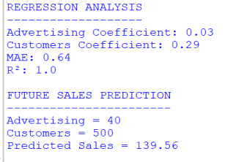
b. To apply Exponential Smoothing to historical demand data, forecast future demand, and evaluate the accuracy of the forecast.
Input
Historical monthly demand:
120, 125, 132, 128, 140, 145, 150, 148,
155, 162, 168, 175
∙ Training data: First 10 months
∙ Testing data: Last 2 months
∙ Future forecast: Next 3 months
INPUT:
import numpy as np
from statsmodels.tsa.holtwinters import ExponentialSmoothing from sklearn.metrics import mean_absolute_error,
mean_squared_error
# Input: Historical demand
demand = [120, 125, 132, 128, 140, 145,
150, 148, 155, 162, 168, 175]
# Split data
train = demand[:10]
test = demand[10:]
# Create Exponential Smoothing model
model = ExponentialSmoothing(
train, trend="add"
).fit()
# Forecast test data
forecast = model.forecast(2)
# Calculate accuracy
mae = mean_absolute_error(test, forecast)
rmse = np.sqrt(mean_squared_error(test, forecast))
# Display results
print("TIME SERIES ANALYSIS")
print("--------------------")
print("Input Demand:", demand)
print("Actual Demand:", test)
print("Forecast Demand:",
[round(float(x), 2) for x in forecast])
print("MAE:", round(float(mae), 2))
print("RMSE:", round(float(rmse), 2))
# Forecast future demand
future = model.forecast(3)
print("\nFUTURE DEMAND FORECAST")
print("----------------------")
print([round(float(x), 2) for x in future])
OUTPUT:
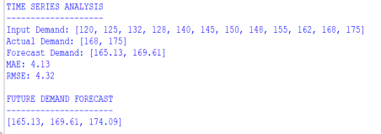
Conclusion: The program uses Exponential Smoothing to forecast future demand and uses MAE and RMSE to evaluate the accuracy of the forecasts.

